Tinder Mini

Software Development Plan

Version 1.3

Revision History

|  |  |  |  |
| --- | --- | --- | --- |
| **Date** | **Version** | **Description** | **Author** |
| 30/10/2022 | 1.0 | Introduction, Overview, Organization | Nguyen Hai Dang |
| 01/11/2022 | 1.1 | Management Process | Nguyen Quang Hien |
| 02/11/2022 | 1.2 | Final Document (Fix errors) | Nguyen Hai Dang, Nguyen Quang Hien |
| 16/11/2022 | 1.3 | Final Document (Fix errors) | Nguyen Hai Dang, Nguyen Quang Hien |

Table of Contents

1. Introduction 4

1.1 Purpose 4

1.2 Scope 4

2. Project Overview 4

2.1 Project Purpose, Scope, and Objectives 4

2.2 Assumptions and Constraints 4

2.3 Project Deliverables 4

3. Project Organization 5

3.1 Organizational Structure 5

3.2 Roles and Responsibilities 5

4. Management Process 6

4.1 Project Estimates 6

4.2 Project Plan 7

4.2.1 Phase and Iteration Plan 7

4.2.2 Releases 7

4.2.3 Project Schedule 7

4.3 Project Monitoring and Control 8

4.3.1 Reporting 8

4.3.2 Risk Management 8

4.3.3 Configuration Management 8

Software Development Plan

# 

# Introduction

## Purpose

This Software Development Plan will cover the activities to develop Tinder Mini application on Android phone device in stages.

## Scope

This Software Development Plan describes the plan for developing the Tinder Mini application as a CSC13002 subject project – Introduction to Software Engineering.

# Project Overview

## Project Purpose, Scope, and Objectives

The main goal of the Tinder project is to provide and train team members to follow a generally agreed upon software development process to build software. The second goal is to build a future version of the Tinder Mini app.

## Assumptions and Constraints

Project has a fixed schedule of 12 weeks

Budget: if tools must be used to assist, there may be a fee.

The project has enough 5 members, do not add other members outside.

Members who miss the assigned deadline will have points deducted if there is no valid reason.

The application may be incomplete, or some features may be changed from the original if it is beyond the team's ability to complete.

## Project Deliverables

The following deliverables will be produced during the project:

• Software Development Plan (this document)

• Vision Statement

• Revised project plan

• Revised vision document

• Use case document with a revised use case model

• Design document (including UI prototypes, architecture document)

• Test plan

• Weekly reports.

*•* Revised artifacts submitted in Elaboration

*•* Test cases

*•* Source code

*•* Test report

*•* Defects

# Project Organization

## Organizational Structure

## Roles and Responsibilities

|  |  |  |
| --- | --- | --- |
| Person | Role | Responsibilities |
| Nguyen Hai Dang | Team Lead, Project Manager | Login, Logout, Register, Project Manager |
| Nguyen Quang Hien | Developer | Suggest Paring, Notifications, Reminders |
| Ho Si Duc | Developer, Business Analyst | Handle Sending & Receiving Text Messages, Image/Audio/Video, Location |
| Nguyen Van Hieu | Designer, Tester | Design App Interface, Message & matching interface, Entertainments Interface |
| Nguyen Khac Tan | Developer | Create Profile, edit profile, entertainments |

# Management Process

## Project Estimates



## Project Plan

### Phase and Iteration Plan



### Releases



### Project Schedule

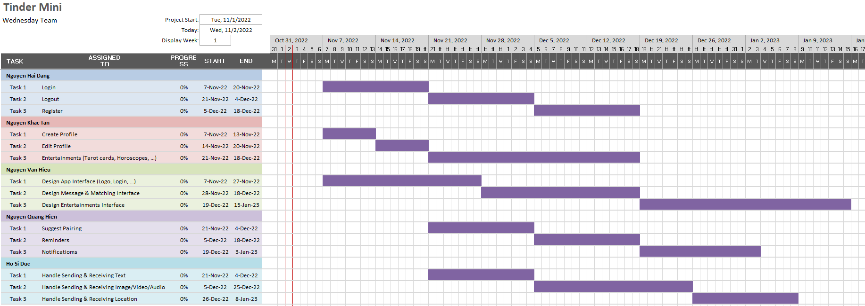

## Project Monitoring and Control

### Reporting



### Risk Management



### Configuration Management

OneDrive: used to manage documents related to the software.

Github: used to store, manage source code, work in groups. Link: [dangcpr/TinderMini: Project of Introduction To Software Engineering - HK1 21/22 - Team 16 (github.com)](https://github.com/dangcpr/TinderMini)

Trello: used to manage the time of the project, following the Agile model. Link: [Tinder Mini - NMCNPM (tindermini) | Trello](https://trello.com/w/tindermini)

Messenger: to communicate with group members.